**Carrick Club’s Two Day Motocross 2012**

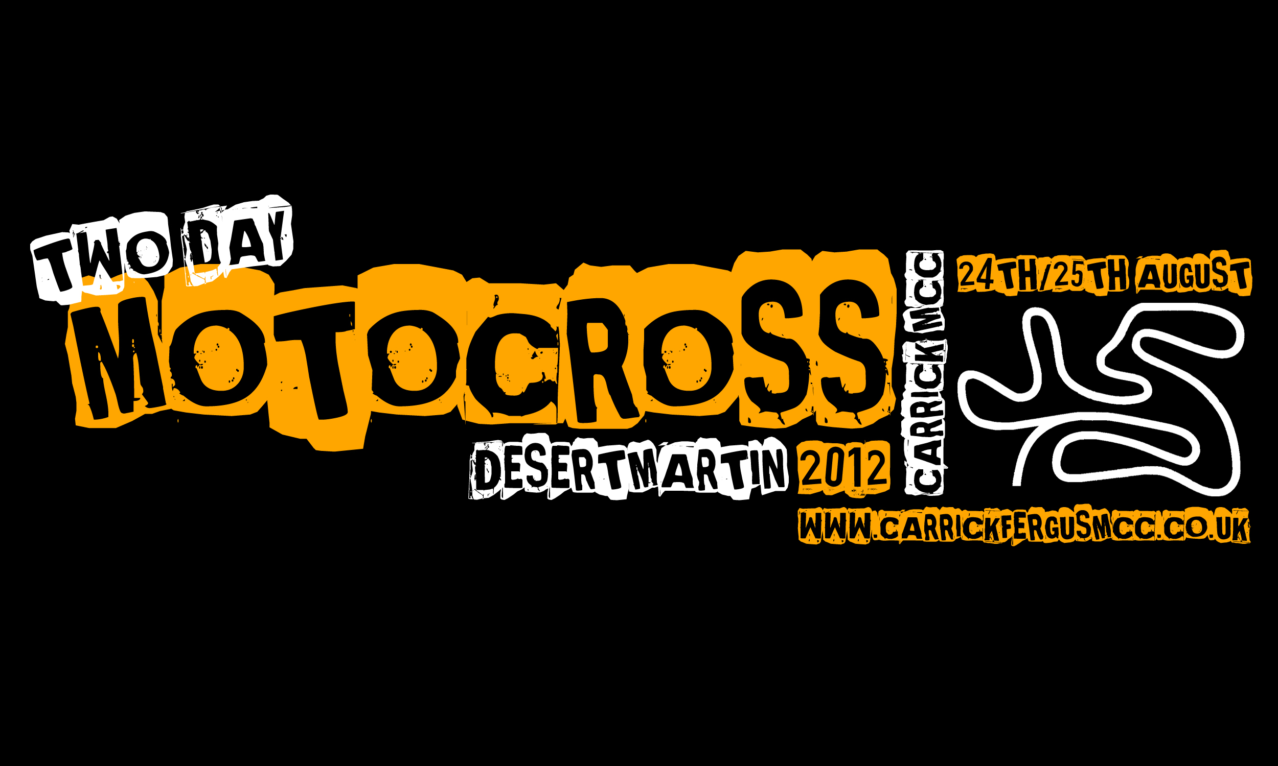

**Friday 24th & Saturday 25th August**

**DESERTMARTIN GP CIRCUIT**

The full circuit including the back section will be used on both days; opportunities to race The Desert with the back section are rare so make use of the chance.

**LIVE BAND FRIDAY EVENING – STRICTLY NO BALLROOM**

(As seen in The Empire)

**CASH FOR KIDS CHARITY CONTRIBUTION**

£5 from every competitor’s entry fee will be donated to the ‘Cash for Kids’ Charity

**FORMAT**

**Solo Classes:** Premier Open | Semi-Expert Open | Clubman Open (x2)

**Quad Classes:** Premier Quad | Clubman Quad (Combined class but scored separate)

**Friday Format**

15 mins free practice

15 mins qualifying practice

2 races

**Saturday Format**

8 mins warm up

3 races

Cash for Kids Feature Race (TBC)

Race Time: Premier Open– 20mins + 1 lap | Semi-Expert & Quad – 15mins + 1 lap | Clubman 12mins + 1

**OFFICIAL ENTRY FORM**

DON’T MISS OUT; SEND YOUR ENTRY TO US NOW TO BOOK YOUR PLACE!

AFTERALL, WE HAVE EVEN SUPPLIED A FORM FOR YOU



Please TURN OVER for

Entry Form and Regulations

CARRICKFERGUS AND DISTRICT MOTORCYCLE CLUB PROMOTION

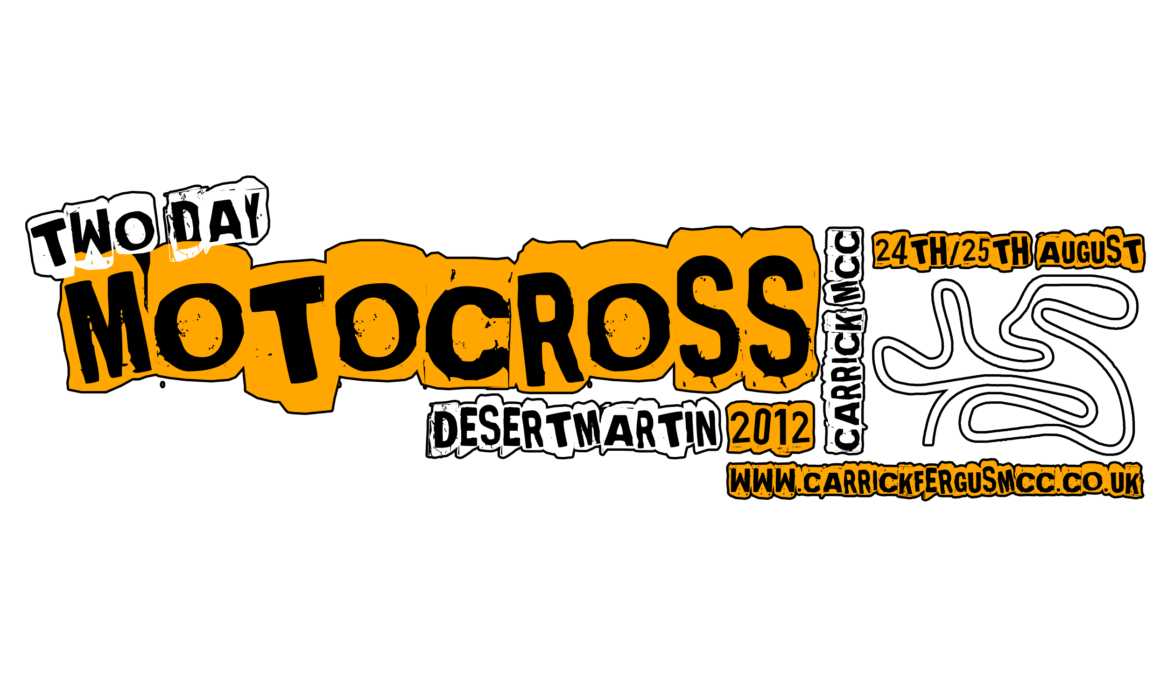

**TWO DAY MOTOCROSS**

FRI. 24TH AND SAT. 25TH AUGUST

DESERTMARTIN GP CIRCUIT OFFICIAL ENTRY FORM

To be held under the Motorcycle Racing Association (Ireland) Ltd, Competition Rules and Standing Regulations and Supplementary Regulations as have or maybe issued for the event. MRA (Ireland) Ltd. permit no. MRA/1659

**ENTRY FORM (PLEASE PRINT CLEARLY, FILLING IN ALL DETAILS REQUESTED)**

**[If you require a day licence, please indicate ‘DAY’ under “Com. Licence No.”]**

Name………………………………………………………….... Riding No. ……………………………………………………

Address…………………………………………………………. Grade …………………………………………………………..

…………………………………………………………………….. Com. License No. …………………………………………..

Post Code………………………………………………….….. Machine (s) Make ………………………………………….

Club……………………………………………………………… Capacity …………………………………………………….…

Telephone No. ……………………………………………… **Transponder No.**…………………………………………..

Premier 🞏 | Semi-Expert 🞏 | Clubman Open 🞏 | Premier Quad 🞏 | Clubman Quad 🞏 | **Please tick ✓**

**PERSONAL ACCIDENT INSURANCE**

**IF YOU ARE FROM OUTSIDE IRELAND PERSONAL ACCIDENT INSURANCE MUST BE OBTAINED THROUGH YOUR FEDERATION BEFORE ENTERING OR PARTICIPATING IN AN EVENT**

**MOTORSPORT CAN BE DANGEROUS AND MAY INVOLVE INJURY OR DEATH.**

**You must read and agree to the following declaration and paragraphs below which are designed to create a legally**

**binding relationship in return for you being allowed to enter and compete.**

1) I confirm that the information in this entry form and the information and my acceptance of the terms of my competition licence are correct.

2. I confirm that I understand the nature of the competition I am entering and I am competent to take part.

3. I confirm that any vehicle that I use will comply with the regulations and will be safe and fit for use in the competition.

4 .I will satisfy myself (by sighting lap or otherwise) before taking part that the venue and track is acceptable to me with regard to its features and physical layout (unless prohibited to do so.)

5. I will not take part if I have any doubt about my ability or the safety of the venue.

6. I accept that competition in motor sport may involve the risk of injury or death and I agree to take part at my own risk.

7. Before taking part in the event I will read and be bound by and comply with any regulations and final instructions issued by the organisers, the circuit owners and the regulatory body, MRA/MCUI.

8 I will not participate whilst under the influence of alcohol or intoxicating drugs and that if I am taking any prescribed medication I will inform the event organiser and seek approval to participate before taking part.

9. If under the age of 18. My parent /guardian has read the above and signed the declaration and agreement below.

**Signature of the competitor**………………………………………………………………………………………… **Date**………………………………………………………

**MOTORSPORT CAN BE DANGEROUS AND MAY INVOLVE INJURY OR DEATH**

**PARENT/GUARDIAN DECLARATION AND AGREEMENT**

To allow the applicant to enter the competition you must agree to the matters set out below which are designed to create

legal obligations on you. Sign below only if you agree.

A. I _________________________________ (print name) am the parent/legal guardian of ___________________________________

B. I have read the entry form and declaration completed by the applicant and confirms the answers are true.

C. I confirm that he/she is competent to take part in the event and that any vehicle which he/she will use is safe and fit for the competition.

D. I will, before allowing him/her to take part, satisfy myself that the course and the facilities are safe and will inspect same.

E. I also hereby AGREE that if the applicant should sustain any injury from any cause whilst taking part in the event and as a result bring a claim for compensation against you or the organisers or officials or sponsors or entrants or owners of the venue I WILL INDEMNIFY AND PAY BACK TO YOU any sum which you may be required to pay as a result of such claim.

**Signature of parent/guardian**__________________________________________________ **Date**___________________________

Address (if different from applicant)………………………………………………………………………………………………………………………………………………

**LATE ENTRIES MAY NOT BE ACCEPTED | Entries Close 8pm Saturday 18th August or when full**

**ENTRIES TO: Charlie Woodside, 12 Gorman Close, Greenisland, BT38 8GA- *CHEQUES MADE PAYABLE TO CARRICK MCC***

**> Entry Fee is £55.00 + Admission | £5 is donated from this to Cash For Kids Charity** <

CARRICKFERGUS AND DISTRICT MOTORCYCLE CLUB PROMOTION



**TWO DAY MOTOCROSS**

FRI. 24TH AND SAT. 25TH AUGUST

DESERTMARTIN GP CIRCUIT OFFICIAL ENTRY FORM

To be held under the Motorcycle Racing Association (Ireland) Ltd., Competition Rules and Standing Regulations and Supplementary Regulations as have or maybe issued for the event. MRA (Ireland) Ltd. permit no. MRA/1659

**Sign-on/Scrutineering** - Thurs. 7.30pm - 9pm & Fri. & Sat 7.30am - 9am | **Briefing** - 9.10am | **Practice** - 9.30am

**Paddock Opening Times** - Thurs.4pm until Fri. 9am | **Overnight parking** - Thurs. and Fri. night ONLY

**Schedule subject to change - check www.carrickfergusmcc.co.uk for full schedule**

**1 - Jurisdiction**

The event will be held under the Motorcycle Racing Association (Ireland) Ltd Competition Rules and Standing Regulations including any supplementary regulations as have or may be issued for the event.

**2 - Eligibility**

The event is open to riders competing on solo motorcycles who are holding a current competition license issued by the MRA and MCUI (SC)., A.C.U. or S.A.C.U. & Continental FMN’s.

**3 - Stewards of the meeting**

MRA Steward Robin Kerr (Friday) | Glyn Forsythe (Saturday)

Club Stewards Graeme Millar

Alan Saunders

**4 - Officials**

Clerk of the Course David Crawford

Assistant Clerk of the Course Gavin Lawther & Ryan Denney

Incident Officer Peter Denney

Environmental Officer Brian Rodgers

Child Protection Officer Anne Peoples

Chief Flag Marshal Trevor Barnett

Secretary of meeting Charlie Woodside, 12 Gorman Close, Greenisland, BT38 8GA

**5 - Events**

Classes are as follows: Premier Solo Open (Grade A), Semi-Expert Solo Open (Grade B), Clubman Solo Open (Grade C – split into fastest 40 and second fastest 40), Quad Open Combined (Premier and Clubman – Race together but are scored separately). Each class will get practice, qualifying and five races over two days. Worst result from the five races will be dropped to give the overall result in each class. *A Feature Cash for Kids Charity Solo Race is work in progress and details will be released in the weeks leading up to the event.*

**6 - Awards & Points**

The points system below is what will be used to score each of the five races for each class. Following the completion of the five races each competitors worst result will then be dropped to give the overall result. Trophies and prize money will be presented at the close of racing on Saturday to the top six overall in each class (Excluding the non-qualifier Clubman Class who will just get trophies.). Prize Money allocation will be announced closer to the time of the event.

Points system 1st to 20th ---> 25 | 22 | 20 | 18 | 16 | 15 | 14 | 13 | 12 | 11 | 10 | 9 | 8 | 7 | 6 | 5 | 4 | 3 | 2 | 1

**7 - Entries**

Entries must be on the Official Entry Form Completed in **every detail** and accompanied by the **FULL Entry Fee**. Entry Fees will only be returned in the event of the meeting being cancelled. The promoters reserve the right to refuse any entry or to return any entry already received without assigning a reason.

**Entry Fee** £55.00 + admission paid when entering venue.

**Donations from entry fee** £1 to MRA Riders Benevolent Fund & £5 to Cash for Kids Charity.

**8 - Scrutineering of Machines and Signing on of Drivers/Passengers**

Riders must present their machines and helmet in racing condition at Scrutineering. Crash helmets must bear the 2012 M.R.A. stamp; a helmet stamper will be on duty. A rider must not race any machine not scrutineered. Each rider must have a current competition licence available for inspection when signing on. Anyone without a current 2012 competition licence will have to get a one day licence at £10.00.

**9 - Exhaust Sound Level**

Random noise testing will be carried out by club personnel throughout the meeting and any rider who fails a noise test may be excluded from the meeting. The sound level must not exceed 94 dBA for four strokes and 96dBA for two strokes.

**10 - Course**

One lap measures 1900 metres approx. The course will be marked with rope and posts. Course cutting may entail exclusion. Any driver who leaves the course must return to it at the point at which he left it except where it is advertant and no advantage is gained.

**12 - Practice**

The order and composition of practice, which will commence at 9.30am sharp on Friday will be at the discretion of the clerk of the course and will be announced prior to the start of practice. Drivers will not be permitted to practice outside the official practice period. Riders must complete at least one lap of the course in practice which will be run in a controlled manner for a period between 9.30am and 11.00am on Friday.

**13 - Method of starting**

A clutch start with a back folding starting gate or National Flag will be employed. The Co-Operation of riders in entering the Assembly Area promptly is required.

**14 - Flag Signals**

The International Code of Signals will be used and such signals MUST be obeyed instantly as failure to do so may result in DISQUALIFICATION. A yellow flag with a black cross will indicate the last lap of the race.

**15 - Finish of a race**

To be classified a finisher a competitor must have completed 75% of the distance covered by the race winner and have crossed the finishing line within five minutes after the race winner has finished.

**16 - Stopping a race**

A race if stopped prematurely for reasons of force majeure may be re-run at the discretion of the promoters with the permission of the stewards. A race will be re-run should there be a false start. If a race is stopped because of a rider/s lying on the course that rider or riders will not be allowed to restart the race.

**17 - Signalling**

All signalling for a rider must be carried out from the designated area and the onus is on the competitor to make sure that his signaller complies to this request. Drivers may be penalised if signalling takes place outside this area.

**18 - Work area**

Any work carried out on a machine during a race must be done only in the designated ‘work-area’.

**19** - Any rider refusing medical attention will not be allowed to race further on the day.

**20** - The Club reserves the right to move any competitor to a different grade or group.

**Directions to Desertmartin**

Full directions are available on our club website. Venue will be signposted from Magherafelt. Postcode is BT45 5QW.

**Entries for this event to be returned to the Competition Secretary (Close 18th August)**

Charlie Woodside, 12 Gorman Close, Greenisland, BT38 8GA

E-mail: Charlie@carrickfergusmcc.co.uk

**More Information on this event**

**Club Website:** www.carrickfergusmcc.co.uk | **Twitter:** @carrickmcc | **Facebook:** www.facebook.com/carrickfergusmcc

**MRA Event Line:** 02897 561427

**WARNING – MOTORCYCLE RACING IS DANGEROUS, PERSONS ATTENDING THIS MEETING DO SO ENTIRELY AT THEIR OWN RISK**

It is a condition of admission that all persons having any connection with the promotion and/or conduct of the meeting, including the owners of the land and the drivers and owners of vehicles and passengers in the vehicles, are absolved from all liability arising out of the accidents, howsoever caused, resulting in damage and/or personal injury to spectators.